Task 1
There are no high, medium risks identified in the Microsoft Defender for Cloud.
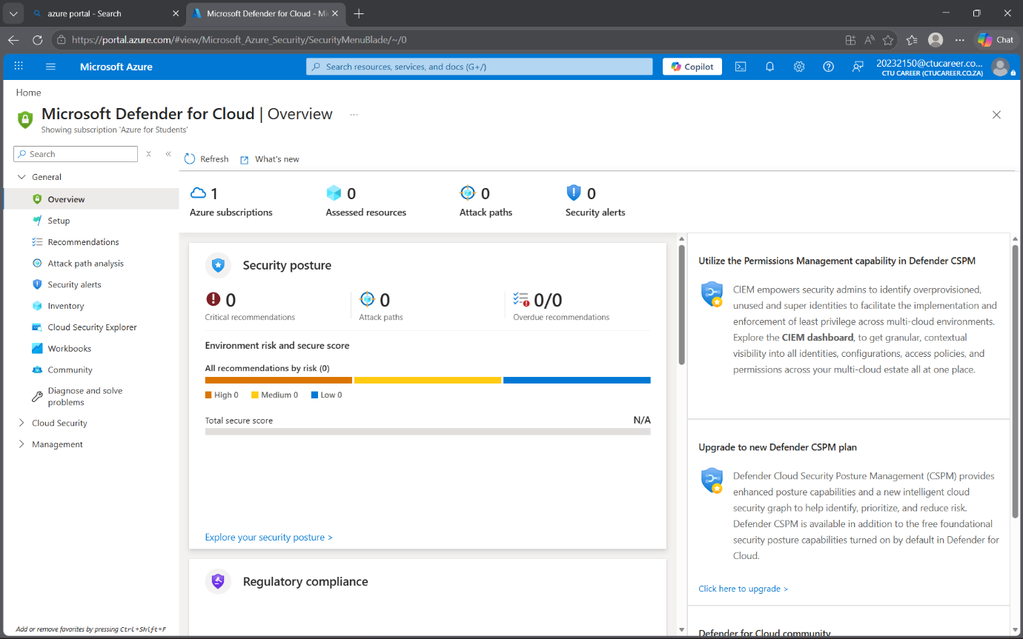
Task 2 – Remediation
2a – The TCP is allowed and the loadbalancer but any outbound traffic is denied.
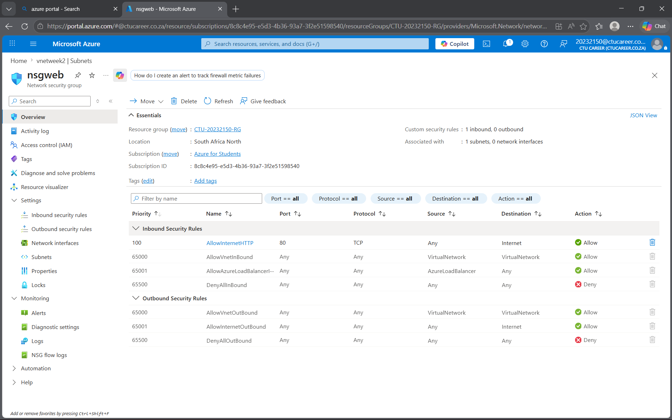
2B – These are the built in configurations in the Virtual machine the subscription provided doesn’t allow me to continue and deploy another rule
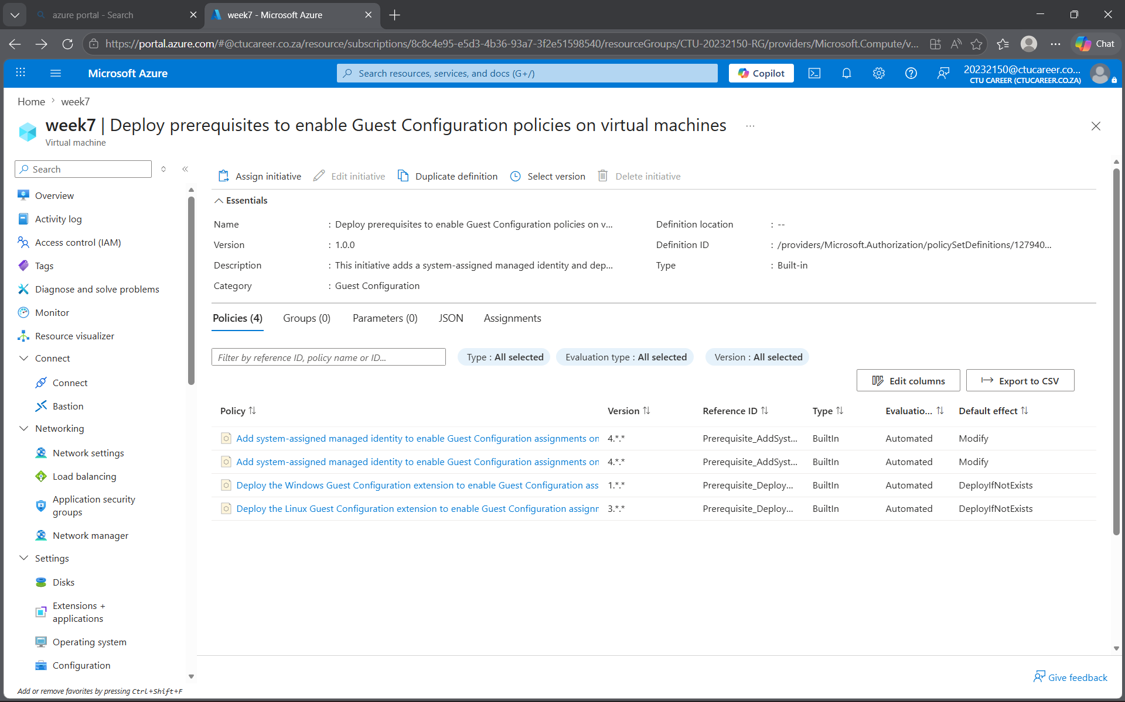
Summary
This task deals mostly about finding in the environment was the exposure of open management ports (RDP on 3389 and SSH on 22) to the public internet. This represents a high-risk attack vector, as these ports are frequently targeted for brute force and remote exploitation attempts. Remediation was prioritized here because closing or restricting these ports immediately reduces the attack surface and prevents unauthorized access. By reconfiguring NSG rules to allow only trusted IP ranges, the environment’s security posture was strengthened while still preserving necessary administrative access.

